Group 19

Name: Nhu Duong

Aditya Kothari

Shanti Stewart

Xiang Zhang

JD Power Supply In-Class Exercise

Today in class we will be doing a brief overview of the JD Power Supply (pspplyjd.0) board. We will start with an overview of the system and then in your groups you will spend time answering the sets of questions below. We will be interrupting you to discuss in class, so it is recommended you only complete the questions in the current section rather than moving on. To answer questions, you will need access to the design files for the pspplyjd.0 design. Those can be found on Canvas under the JD Power Supply Module. [Direct link](https://www.google.com/url?q=https://oregonstate.instructure.com/courses/1668641/pages/power-supply-design-files-pspplyjd-dot-0?module_item_id%3D17637863&sa=D&ust=1547142547609000)

Section 1 - Schematic:

1. Please fill in the table below:

|  |  |
| --- | --- |
| Component | Number in Design |
| Resistors | 12 |
| Capacitors | 8 |
| Connectors | 10 |
| Inductors | 1 |
| Test Pads | 11 |

1. From the datasheet, what is the maximum rated input voltage for the LD1117S33TR?

15 V

1. From the datasheet, what is the maximum current for the TPS54232?

2 A

1. What type of power supply is the 3.3V supply?

Linear

Section 2 - Bill of Materials:

1. What is the package type of C2?

1206(3216 metric), C_1206_HandSoldering

1. Name one electrolytic Capacitor? (i.e. C1, C2)

Polarized C8, example: Cornell Dubilier

1. What package type is the LD1117?

TO-261-4, TO-261AA

Section 3 - Printed Circuit Board:

1. Why are some PCB traces thicker than others?

Thickness depends on the current carrying capacity of the PCB traces and thicker traces carry more current.

1. What test point would reliably give you 5V? How about GND?

T4 for 5V, T11 for GND

1. What is the purpose of flux in soldering?

Prevents oxidation and allows smooth soldering.

1. How might you test for a short between two testing points on the PCB?

Do it at the test points where a drop is expected.

Section 4 - Operation:

1. Given test points T1 and T2, how would you go about measuring the current passing through D1?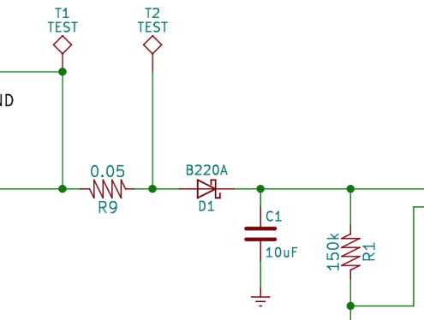

Calculate Voltage drop across R9 and then use Ohm’s law (V=I*R) to calculate the current passing through R9, which would be same as D1

1. What’s the purpose of a 0.01Ohm resistor (like R11)?  
   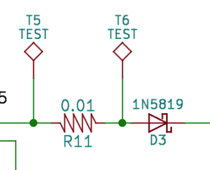

To test current passing through R11.

1. Why use a voltage regulator over using a voltage divider?

We need regulator to get a fixed output voltage as it does not depend on the input voltage.

1. Would you expect the output voltage ripple to be larger or smaller with a smaller resistance tied to the output? Why?

Smaller the resistance, smaller the ripple. Since according to OHM’s law (V=IR), Voltage is directly proportional to resistance

1. For the TPS54232 PMIC, what is the equation to set the output voltage?

